Dr. AMBEDKAR INSTITUTE OF TECHNOLOGY
Near Jnana Bharathi Campus, Bengaluru-560 056.
(An Autonomous Institution, Aided by Government of Karnataka)



Project Report

on
“GROCERY MANAGEMENT SYSTEM”

Submitted By

AMRUTHA.T.A 1DA18CS014
ANUPAMA.A.S 1DA18CS019

Under the Guidance Of

Mrs. ASHA RAMESH
Asst. Prof., Dept of CSE
Dr. AIT

Department of Computer Science & Engineering
2020-21

Dr. AMBEDKAR INSTITUTE OF TECHNOLOGY
Near Jnana Bharathi Campus, Bengaluru-560056.
(An Autonomous Institution, Aided by Government of Karnataka)

CERTIFICATE
This is to certify that the project entitled “Grocery Management System” submitted in the partial fulfillment of the requirement of the 5th semester DBA mini project curriculum during the year 2020-21 is a result of bonafied work carried out by

AMRUTHA.T.A 1DA18CS014
ANUPAMA.A.S 1DA18CS019

Signature of the guides:

________________________
Mrs. ASHA RAMESH
Asst. Prof., Dept of CSE
Dr. AIT

- Internal Examiner _____________
- External Examiner _____________

Dr. SIDDARAJU
HOD & Professor
Department of CSE, Dr.AIT

ACKNOWLEDGEMENT

The satisfaction that accompanies to this project would be incomplete without the mention of the people who made it possible, without whose constant guidance and encouragement would have made our efforts go in vain.

We consider ourselves privileged to express our gratitude and respect towards all those who guided us through the project, “Grocery Management System”.

We would like to express our gratitude to Dr. C Nanjunda Swamy, Principal Dr. AIT, for providing us the congenial environment to work in.

We would like to express our profuse gratitude to Dr. Siddaraju, HOD,Dept. of Computer Science & Engineering, Dr. AIT, for giving us the support, encouragement and providing us the required lab facilities that was necessary for the completion of this project.
As a token of gratitude, we would like to acknowledge our sincere gratefulness to the internal guide Mrs. Asha K N, Assistant Professor, Dept. of CSE, Dr.AIT, for her unlimited support and encouragement provided throughout the process.

We also express our gratitude and sincere thanks to all the teaching and non-teaching staff of Computer Science & Engineering Department.

Finally, yet importantly, we would like to express our heartfelt thanks to our beloved Parents for their blessings and our Friends for their help and wishes for the successful completion of this project report.

AMRUTHA.T.A 1DA18CS014
ANUPAMA.A.S 1DA18CS019

ABSTRACT

The grocery management database system facilitates the grocers whose data is stored in the database and would be easy for the grocer to add and remove data from the database. The aim of this case study is to design and develop a database system, maintaining the records of groceries, bills, customers and the vendors from whom they are buying the grocery. A grocer can enter the data of the groceries which he purchases from the respective vendors and using this data queries can be written to extract the products purchased by the customer for billing purposes. He can also divide the groceries into departments and assign some employees for each department. Each vendor is mapped to multiple groceries. Moreover, multiple groceries belong to certain well-defined departments. So, every purchase from a customer can be filtered by the department to which the product belongs to, the vendor who is assigned that product or both. The employees are assigned to the above-mentioned departments and can be filtered by the same.

TABLE OF CONTENTS
Chapter No. | Title | Page No.
Chapter 1 | Introduction  1.1 Project Description
Chapter 2 | Software Requirement specification  2.1 Hardware requirements  2.2 Software requirements  2.3 Functional requirements  2.4 Non-functional requirements
Chapter 3 | Description  3.1 SQL  3.2 Entity Relationship Diagram(ER Diagram)
Chapter 4 | Implementations  4.1 Creation of Tables  4.2 Insertion of tables  4.3 Queries
Chapter 5 | Conclusion
 | Bibliography

Chapter 1

INTRODUCTION

Database is an organized collection of data. The data is typically organized to model aspects of reality in a way that supports processes requiring information. A DBMS makes it possible for end users to create, read, update and delete data in a database. It essentially serves as an interface between the database and end users or application programmers, ensuring that data is consistently organized and remains easily accessible.

The DBMS manages three important things: the data, the database engine that allows data to be accessed, locked and modified and the database schema, which defines the database’s logical structures. These three foundational elements help provide concurrency, security, data integrity and uniform administration procedures. It can offer both logical and physical data independence, that means it can protect users and applications from needing to know where data is stored or having to be concerned about changes to physical structure of data.

The main purpose of maintaining database for Grocery Management System is to reduce the manual errors involved in the inserting and billing of products and make it convenient for the grocers to maintain the data about their groceries and also about the vendors from whom they bought the groceries. Due to automation many loopholes that exist in the manual maintenance of the records can be removed. The speed of obtaining and processing the data will be fast. For future expansion, the proposed system can be enabled so that retailers can make various queries to manipulate their data of groceries, customers and vendors. So, we design a database which includes grocery details, customer details, vendor details and the information of the grocery being sold by the grocer.

1.1 PROJECT DESCRIPTION

The “Grocery shop Management” has been developed to override the problems prevailing in the practicing manual system. This software is supported to eliminate and, in some cases, reduce the hardships faced by this existing system. Moreover, this system is designed for the particular need of the company to carry out operations in a smooth and effective manner.

The application is reduced as much as possible to avoid errors while entering the data. It also provides error message while invalid data. No formal knowledge is needed for the user to use this system. Thus, by this all it proves it is user-friendly. Grocery shop Management System, as described above, can lead to error free, secure, reliable and fast management system. It can assist the user to concentrate on their other activities rather to concentrate on the record keeping. Thus, it will help organization in better utilization of resources.

Chapter 2

REQUIREMENT SPECIFICATION

The hardware and software components of a computer system that are required to install and use software efficiently are specified in the SRS. The minimum system requirements need to be met for the program to run at all times on the system.

2.1 Hardware Requirements

The hardware requirement specifies the necessary hardware which provides us the platform to implement our programs.
- 2.2GHz processor
- 4 GB RAM
- 10 GB ROM
- VGA capable of 1960x1080 screen resolution
- Necessary computer peripherals such as keyboard etc.

2.2 Software Requirements

The software requirement specifies the pre-installed software needed to run the code being implemented in this project.

- My SQL Workbench
- Windows Operating system.

2.3 Functional Requirements

The database needs to satisfy the following requirements
- Maintains the information about customers and bills
- Records of products and vendors.
- Divides the products into departments.
- Display the product and customer details in an easily readable, graphical way.
- Display the details of the products which have been sold.

2.4 Non-functional requirements

- Unique product id to be provided for each product.
- Unique customer id to be provided for the customers who purchase the products sold by the retailer.
- Only the retailer has the access to update the database.
Chapter 3

DESCRIPTION

Database is a collection of inter-related data which helps in efficient retrieval, insertion and deletion of data from database and organizes the data in the form of tables, views, schemas, reports etc. For Example, university database organizes the data about students, faculty, and admin staff etc. which helps in efficient retrieval, insertion and deletion of data from it. The software which is used to manage database is called Database Management System (DBMS). For Example, MySQL, Oracle etc. are popular commercial Database Management Systems used in different applications. This project has been designed using MY SQL WORKBENCH.

3.1 SQL

SQL stands for Structured Query Language. It is a language used to interact with the database, i.e. to create a database, to create a table in the database, to retrieve data or update a table in the database etc. SQL is an ANSI (American National Standards Institute) standard. Using SQL, we can do many things, for example – we can execute queries, we can insert records in a table, we can update records, we can create a database, we can create a table, we can delete a table etc. It is true that SQL is a language but it does not support programming as it is not a programming language, it is a command language. We do not have conditional statements in SQL like for loops or if else, we only have commands which we can use to query, update delete etc. data in the database. SQL allows us to manipulate data in a database.

3.2 ENTITY RELATIONSHIP DIAGRAM

An entity relationship diagram (ERD), also known as an entity relationship model, is a graphical representation of an information system that depicts the relationships among people, objects, places, concepts or events within that system. An ERD is a data modeling technique that can help define business processes and be used as the foundation for a relational database.
Entity relationship diagrams provide a visual starting point for database design that can also be used to help determine information system requirements throughout an organization. After a relational database is rolled out, an ERD can still serve as a referral point, should any debugging or business process re-engineering be needed later. However, while an ERD can be useful for organizing data that can be represented by a relational structure, it can't sufficiently represent semi-structured or unstructured data. It's also unlikely to be helpful on its own in integrating data into a pre-existing information system.

There are three basic components of an entity relationship diagram:
- Entities, which are objects or concepts that can have data stored about them.
- Attributes, which are properties or characteristics of entities. An ERD attribute can be denoted as a primary key, which identifies a unique attribute, or a foreign key, which can be assigned to multiple attributes.
- The relationships between and among those entities.
For example, an ERD representing the information system for a company's sales department might start with graphical representations of entities such as the sales representative, the customer, the customer's address, the customer's order, the product and the warehouse. (See diagram above.) Then lines or other symbols can be used to represent the relationship between entities, and text can be used to label the relationships.
The three main cardinalities are:

- A one-to-one relationship (1:1). For example, if each customer in a database is associated with one mailing address.
- A one-to-many relationship (1: N). For example, a single customer might place an order for multiple products. The customer is associated with multiple entities, but all those entities have a single connection back to the same customer.
- A many-to-many relationship (M: N). For example, at a company where all call center agents work with multiple customers, each agent is associated with multiple customers, and multiple customers might also be associated with multiple agents.

ER-diagram

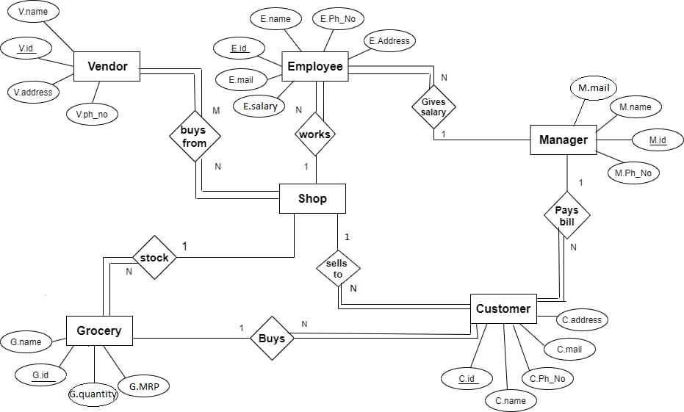
Fig.1 ER Diagram

RELATIONAL SCHEMA

A relational database schema is the tables, columns and relationships that make up a relational database. A relational database schema helps you to organize and understand the structure of a database. In fact, database schema is the skeleton of the database representing the logical view of the entire database. This is particularly useful when designing a new database, modifying an existing database to support more functionality, or building integration between databases. There are two steps to creating a relational database schema: creating the logical schema and creating the physical schema.

- The logical schema depicts the structure of the database, showing the tables, columns and relationships with other tables in the database and can be created with modeling tools or spreadsheet and drawing software.
- The physical schema is created by actually generating the tables, columns and relationships in the relational database management software (RDBMS). Most modeling tools can automate the creation of the physical schema from the logical schema, but it can also be done by manually.

The structure of a relational database will inevitably change over time as data needs change. It's just as important to document changes to your relational database schema as it was to document the original design, otherwise it becomes increasingly difficult to update or integrate the database.

Relational schema diagram
Vendor

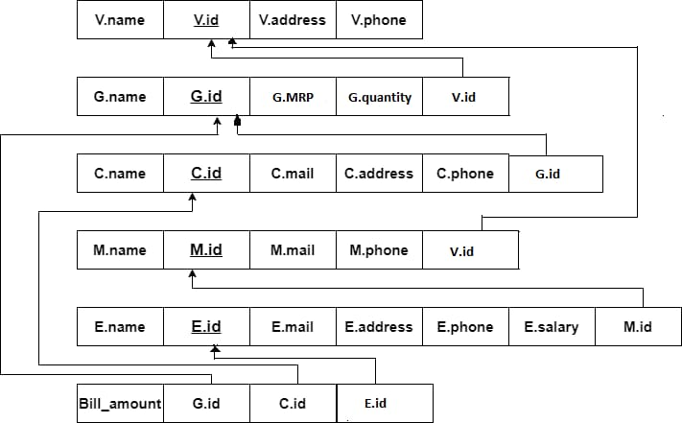
Grocery
Customers
Manager
Employee
Bill
Fig.2 Relational schema
Chapter 4

IMPLEMENTATION

4.1 Creation of tables

CREATE TABLE VENDOR(
VID NUMBER(10) NOT NULL,
VNAME VARCHAR(45) NOT NULL,
VADDRESS VARCHAR(45) NOT NULL,
VPHONE NUMBER(10) NOT NULL,
CONSTRAINT VENDOR_VID PRIMARY KEY (VID));

CREATE TABLE GROCERY (
GID NUMBER(10) NOT NULL,
GNAME VARCHAR(30) NOT NULL,
GQUANTITY NUMBER(10) NOT NULL,
GMRP NUMBER(20) NOT NULL,
CONSTRAINT GROCERY_GID PRIMARY KEY(GID),
VID NUMBER(10) NOT NULL,
FOREIGN KEY(VID) REFERENCES VENDOR(VID));

CREATE TABLE CUSTOMERS(
CID NUMBER(10) NOT NULL,
CNAME VARCHAR(30) NOT NULL,
CEMAIL VARCHAR(40)NOT NULL,
CPHONE NUMBER(10) NOT NULL,
CADDRESS VARCHAR(40) NOT NULL,
GID NUMBER(10) NOT NULL,
CONSTRAINT CUSTOMERS_CID PRIMARY KEY(CID),
FOREIGN KEY(GID) REFERENCES GROCERY(GID));

CREATE TABLE MANAGER(
MNAME VARCHAR(30) NOT NULL,
MID NUMBER(10) NOT NULL,
MPHONE NUMBER(10) NOT NULL,
MMAIL VARCHAR(40) NOT NULL,
VID NUMBER(10) NOT NULL,
CONSTRAINT MANAGER_MID PRIMARY KEY(MID),
FOREIGN KEY(VID) REFERENCES VENDOR(VID));

CREATE TABLE EMPLOYEE (
ENAME VARCHAR(30) NOT NULL,
EID NUMBER(10) NOT NULL,
EPHONE NUMBER(10) NOT NULL,
EADDRESS VARCHAR(30) NOT NULL,
EMAIL VARCHAR(40),
ESALARY NUMBER(20) NOT NULL,
MID NUMBER(10) NOT NULL,
FOREIGN KEY(MID) REFERENCES MANAGER(MID),
CONSTRAINT CUSTOMERS_EID PRIMARY KEY(EID));

CREATE TABLE BILL(
BILL_AMOUNT NUMBER(25) NOT NULL,
GID NUMBER(10) NOT NULL,
CID NUMBER(10) NOT NULL,
EID NUMBER(10) NOT NULL,
FOREIGN KEY(EID) REFERENCES EMPLOYEE(EID),
FOREIGN KEY(GID) REFERENCES GROCERY(GID),
FOREIGN KEY(CID) REFERENCES CUSTOMERS(CID));

4.2 Insertion of values
INSERT INTO VENDOR VALUES (01,'ANUPAMA','BANGALORE',9380688630);
INSERT INTO VENDOR VALUES (02,'AMRUTHA','CHENNAI',9483248659);
INSERT INTO VENDOR VALUES (03,'ANANYA','MYSORE',9480083159);
INSERT INTO VENDOR VALUES (04,'ATMIKA','BELAGAVI',8762713859);

INSERT INTO GROCERY VALUES(11,'RICE',17,500,03);
INSERT INTO GROCERY VALUES(12,'WHEAT',9,253,02);
INSERT INTO GROCERY VALUES(13,'JOWER',7,169,03);
INSERT INTO GROCERY VALUES(14,'PULSES',11,153,01);
INSERT INTO GROCERY VALUES(15,'DAALS',22,96,04);

INSERT INTO CUSTOMERS VALUES(21,'SMITHA','SMITHA@GMAIL.COM',8710369745,'SHIMOGA',11);
INSERT INTO CUSTOMERS VALUES(22,'TARUN','TARUN@GMAIL.COM',9345678874,'BANGALORE',13);
INSERT INTO CUSTOMERS VALUES(23,'RAJ','RAJ@GMAIL.COM',8454679801,'BANGALORE',15);
INSERT INTO CUSTOMERS VALUES(24,'PRASHANTH','PRASHANTH@GMAIL.COM',9460813590,'CHENNAI',11);
INSERT INTO CUSTOMERS VALUES(25,'VARUN','VARUN@GMAIL.COM',9583172678,'MYSORE',12);
INSERT INTO CUSTOMERS VALUES(26,'PUNEETH','PUNEETH@GMAIL.COM',9068860839,'CHIKMAGALUR',14);

INSERT INTO MANAGER VALUES('SURESH',51,9843426895,'SURESH@GMAIL.COM',03);
INSERT INTO MANAGER VALUES('VEENA',52,9368680830,'VEENA@GMAIL.COM',02);
INSERT INTO MANAGER VALUES('KSHAMA',53,6278718395,'KSHAMA@GMAIL.COM',03);
INSERT INTO MANAGER VALUES('SUJANA',54,7979572618,'SUJANA@GMAIL.COM',01);

INSERT INTO EMPLOYEE VALUES('ANU',31,9872318699,'BANGALORE','ANU@GMAIL.COM',17000,54);
INSERT INTO EMPLOYEE VALUES('DIVYA',32,9980446271,'KARWAR','DIVYA@GMAIL.COM',15320,53);
INSERT INTO EMPLOYEE VALUES('PRAJWAL',33,9060785124,'RAMNAGAR','PRAJWAL@GMAIL.COM',19220,51);
INSERT INTO EMPLOYEE VALUES ('SUMANTH',34,6362734929,'SHIMOGA','SUMANTH@GMAIL.COM',11432,51);
INSERT INTO EMPLOYEE VALUES('VIDYA',35,7279462489,'BANGALORE','VIDYA@GMAIL.COM',20150,52);

INSERT INTO BILL VALUES(7000,11,21,31);
INSERT INTO BILL VALUES(5040,11,25,32);
INSERT INTO BILL VALUES(1000,13,22,33);
INSERT INTO BILL VALUES(9840,12,24,34);
INSERT INTO BILL VALUES(2500,13,23,35);
INSERT INTO BILL VALUES(5400,14,21,31);
INSERT INTO BILL VALUES(9000,15,21,31);

4.3 Insertion of values
DESC VENDOR;
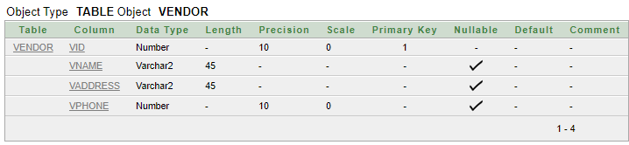

DESC GROCERY;
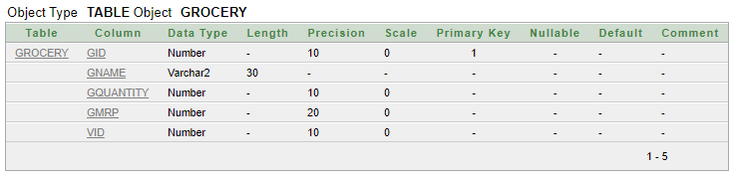

DESC CUSTOMERS;
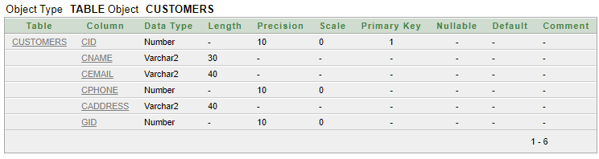

DESC MANAGER;
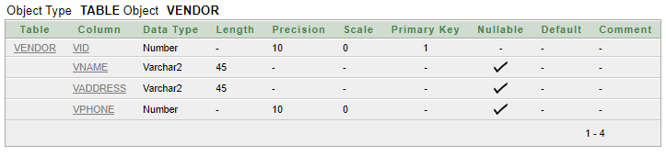

DESC EMPLOYEE;
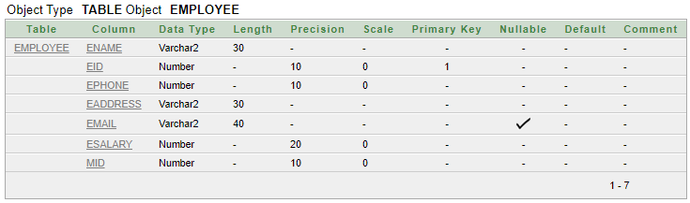

DESC BILL;
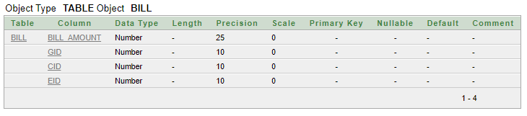

SELECT * FROM VENDOR;
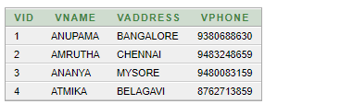

SELECT * FROM GROCERY;
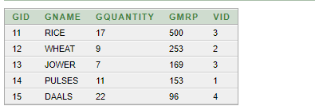

SELECT * FROM CUSTOMERS;
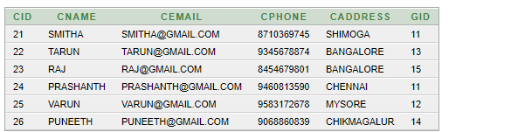

SELECT * FROM MANAGER;
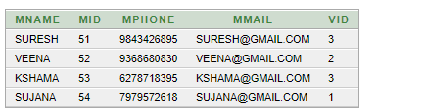

SELECT * FROM EMPLOYEE;
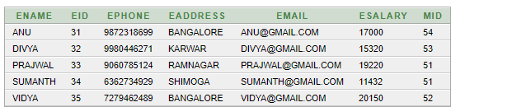

SELECT * FROM BILL;
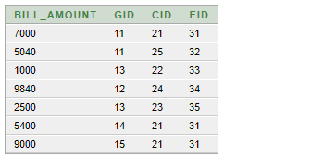

4.3 Queries
- Display the employee name and his/her salary whose salary is less than the average salary of all.
SELECT E.ENAME, E.ESALARY FROM EMPLOYEE E
WHERE E.ESALARY < (SELECT AVG (ESALARY)
FROM EMPLOYEE);
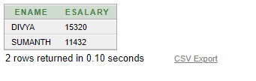

- Display the details of the vendor who give grocery to the manager name=’suresh’.
SELECT * FROM VENDOR V, MANAGER M
WHERE V.VID=M.VID AND MNAME='SURESH';
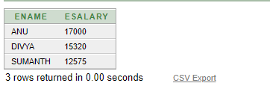

- Display the details of grocery bought for maximum amount from a customer.
SELECT * FROM GROCERY G, BILL B
WHERE G.GID=B.GID AND BILL_AMOUNT= (
SELECT MAX (BILL_AMOUNT) FROM BILL);
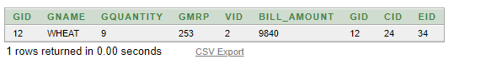

- Update the salary of employee whose come under the manager id=51.
UPDATE EMPLOYEE SET ESALARY=1.1*ESALARY
WHERE EID IN (SELECT EID FROM EMPLOYEE
WHERE MID=51);
SELECT * FROM EMPLOYEE;
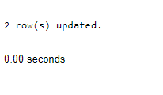
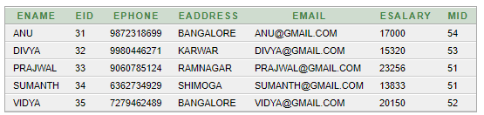

- Display the details of employee whose address is other than bangalore.
SELECT * FROM EMPLOYEE
WHERE EADDRESS NOT IN (SELECT
EADDRESS FROM EMPLOYEE
WHERE EADDRESS='BANGALORE');
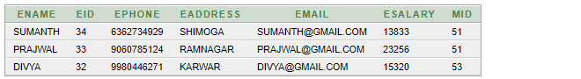

Chapter 5
CONCLUSION
The grocery management system for computerizing the database. This is capable to provide easy and effective staorage of information related grocery and other data. It also include modifying data with these, the objectives of the system design will be activated.
In comparison with manual system the benefits under this system are considerable in the saving of man power working hours and effort.
The project can be used to make better management of the database. The user gets timely information.
BIBLIOGRAPHY

Few of the books and websites have been instrumental in helping us complete this project. They are mentioned below.

Books:
1. Elmasri and Navathe,” Fundamentals of Database System”, Addision-Wesley, 6th Edition, 2007

URLs:

- https://stackoverflow.com/

- https://www.w3schools.com/sql/default.asp

- https://www.geeksforgeeks.org/sql-tutorial/

- https://www.google.com/

